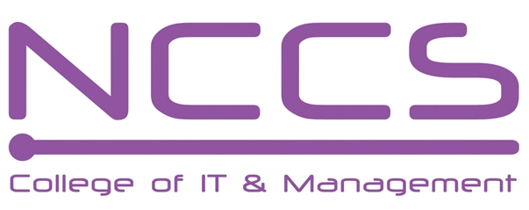
National College of Computer Studies
(NCCS-College of IT & Management)
Final Examination (2021)
BSc.CSIT/First Semester/ CSC 111 : Digital Logic

Candidates are required to answer the questions in their own words as far as practicable.

Full Marks: 60
Pass Marks: 30
Time: 3 Hours
Set A

Attempt any two questions. [2×10=20]
- What is magnitude comparator? Design and Explain 4-bit magnitude comparator.
- What are asynchronous counter? Design synchronous counter that counts the sequences of 1-3-6-7-1-0 and repeat using T flip-flop.
- Implement the following functions using a. Multiplexer b. Decoder c. PAL
F(A,B,C,D)=∑(0,1,5,7,8,10,14,15).

Attempt any eight questions. [8×5=40]
- If A=-29 and B=-20 then perform A-B and B-A using 2’s complement.
- If F(P,Q,R,S)= Σ (3,4,7,8,14) and d(P,Q,R,S)= Σ(1,6,9,13),Simplify it using K-map and design circuit using minimum number of NAND gates.
- Design 8 to 3-line Encoder using NAND gate only.
- Design a full subtractor circuit using Programmable Logic Array.
- Design and Explain4 bit Serial in serial Out shift Register with timing Diagram.
- Implement a circuit which accepts 3 bit inputs and output exceed square of input by3using ROM.
- Design asynchronous Decade counter with state diagram, logical diagram and timing diagram.
- Explain about flip-flop which is the single input version of RS flip-flop with logical diagram, characteristics table, characteristics equation and excitation table.
- Write short notes on:
a.) State Diagram
b.) Reflected Code
c.) Johnson counter
********

